**SUBSCRIBERS GALORE:EXPLARING WORL’S TOP YOUTUBE CHANNELS:**

**Submitted by**

**S.AL MURSITHA BEGAM**

**Team id**

**NM2023TMID25748**

**Team members id**

**AL MURSITHA BEGAM S:63F85D4243C9CDAFE944CB2D83DF090**

**ANANTHI.M :B443BD9C61DAE409B4B42EB7E4898B7D**

**ANNA KODI.T:D85AE7830D0E4EEB3E640654224EB92D**

**ARULJOTHI.S:3930B7EA14FC06AADFD427887F0DD12C**

Under the guidance of

**Dr. A. Beulah Mary**

**Assistant Professor**

**Department of Physics**



**October 2023**

**Sri Meenakshi Government Arts College for Women (A)**

**Madurai – 625 002**

**Project Reports Template**

**1.Introdution**:

**1.1:Overview**:

Youtube intro videos are short ,introductory clips that play at the beginning of a youtube video.They usually include the title of the youtube channel ,brand features like logos and colors, animation and an accompanying snippet of music.

**1.2:Purpose:**

**Use**:Watch and like videos and subscribe to channel with google account.But without a youtube channel ,you have no public presence on youtube.comment or make play lists.

**Achivement by using this:**

**Silver:**When you reach 100000 subscribers.

**Gold:**when you reach 1000000 subscribers.

**Diamond:**When you reach 10000000 subscribers.

**Red Diamond:**When you reach 100000000 subscribers.

**2.Problem Definition and Design Thinking**:

**2.1:Empathy Map:**

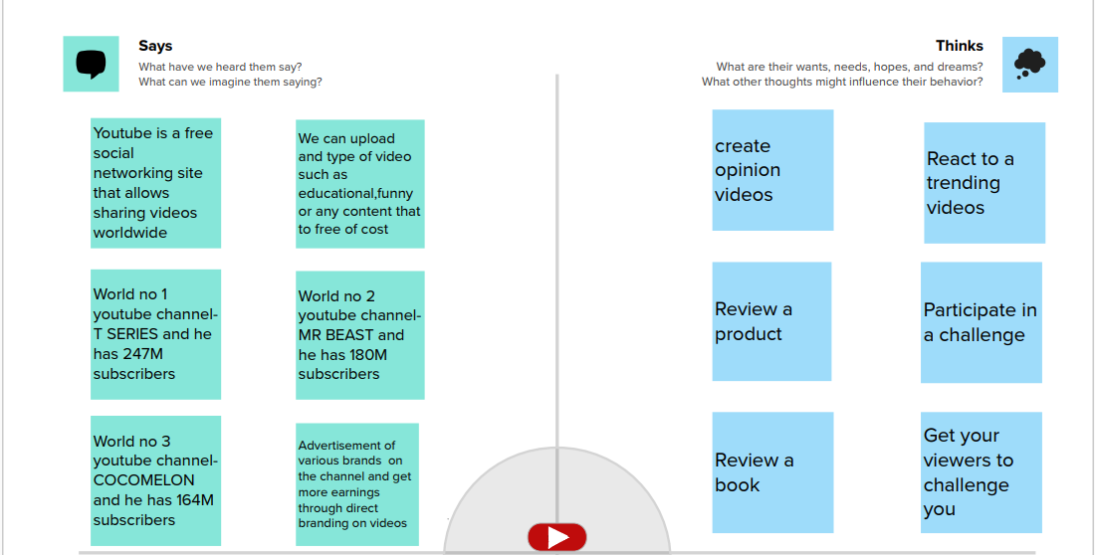

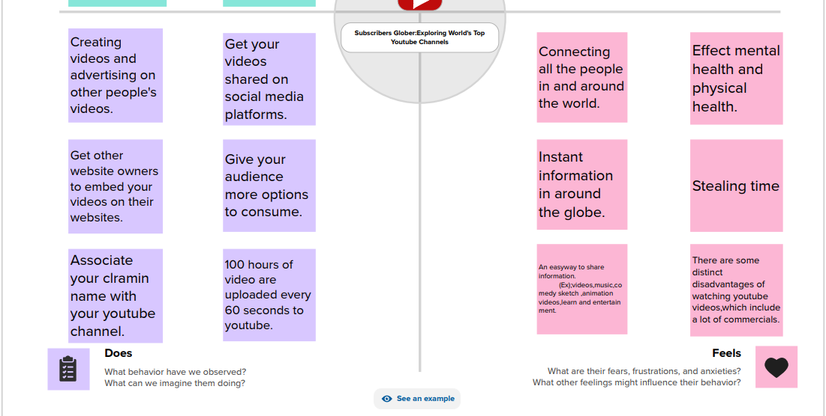

**2.2 Ideation and Brainstoming Map:**

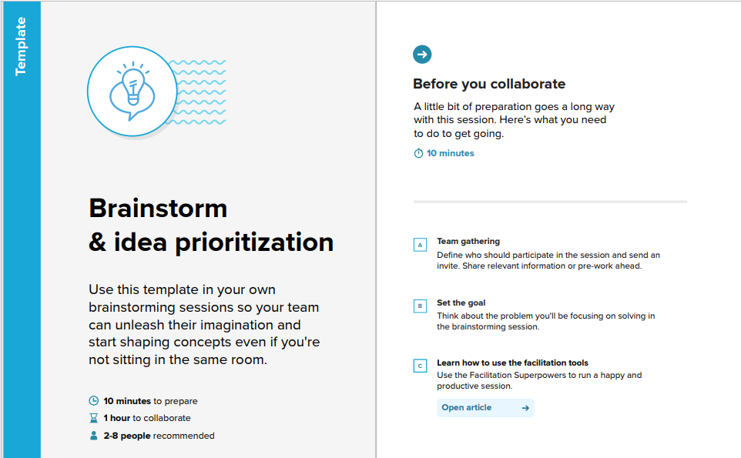

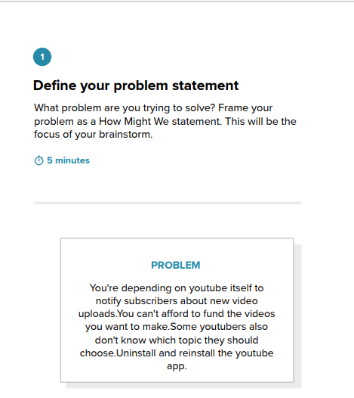

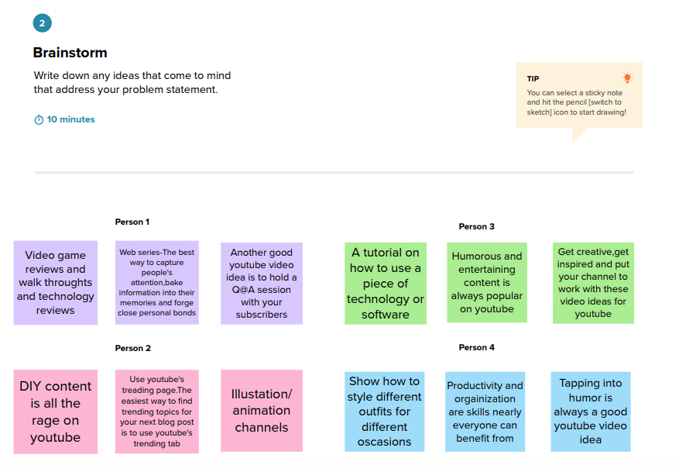

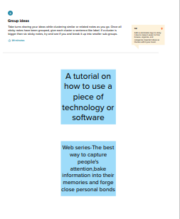

**3.Result(output of the project along with S.S):**

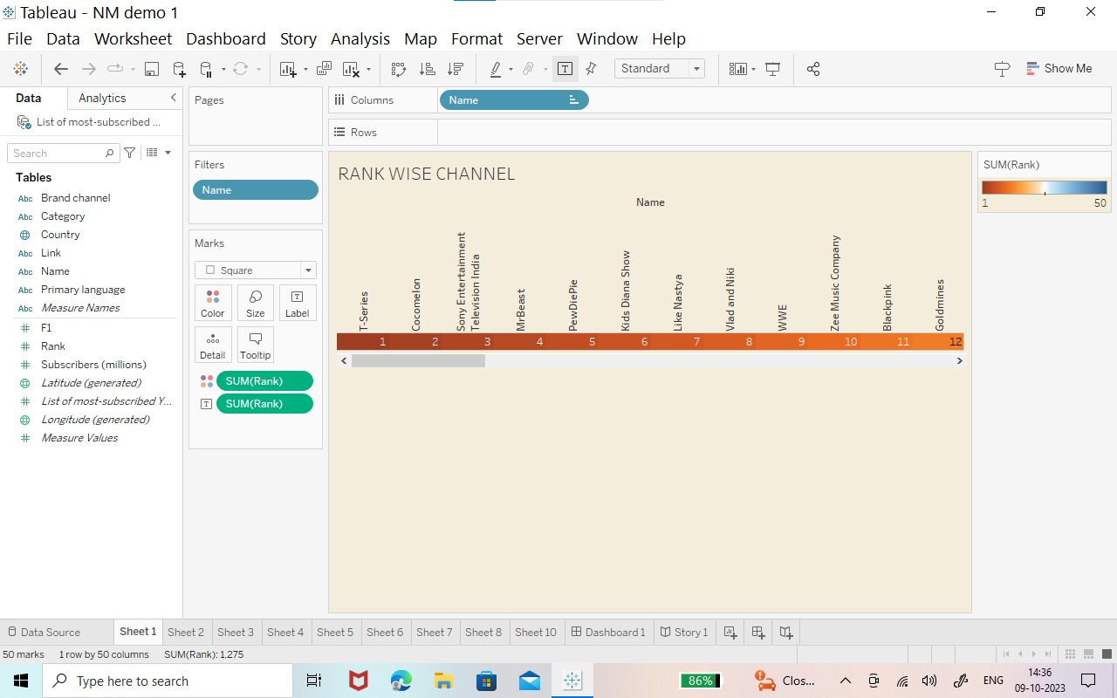

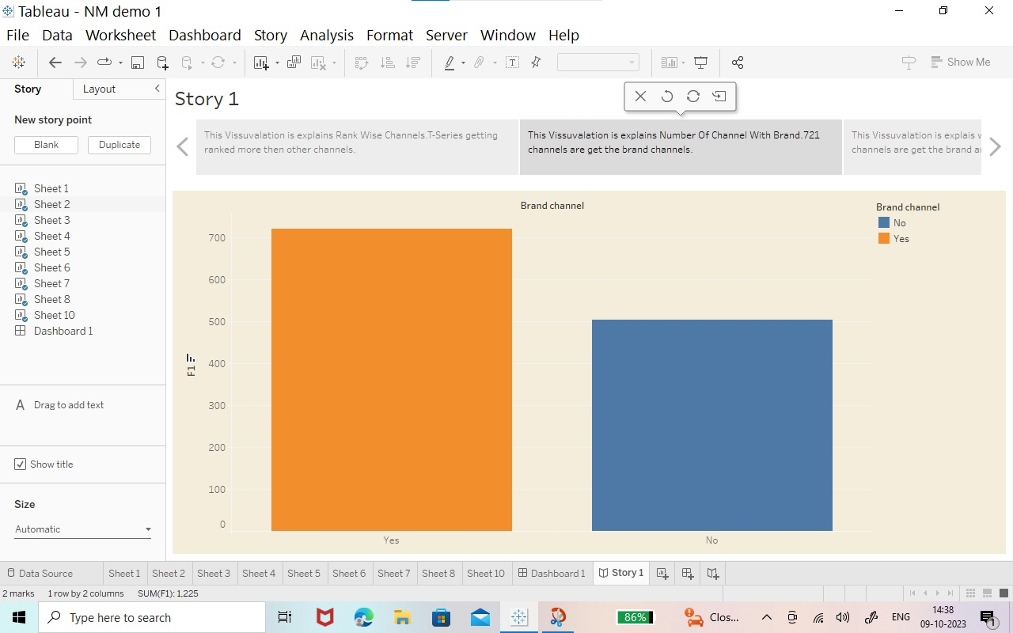

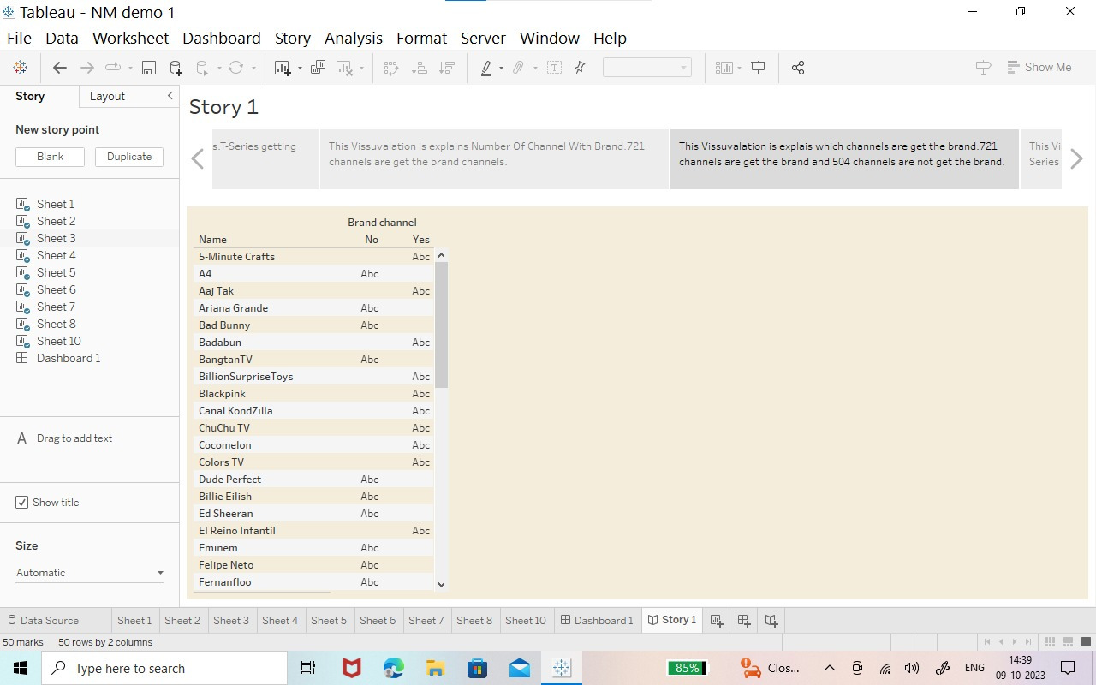

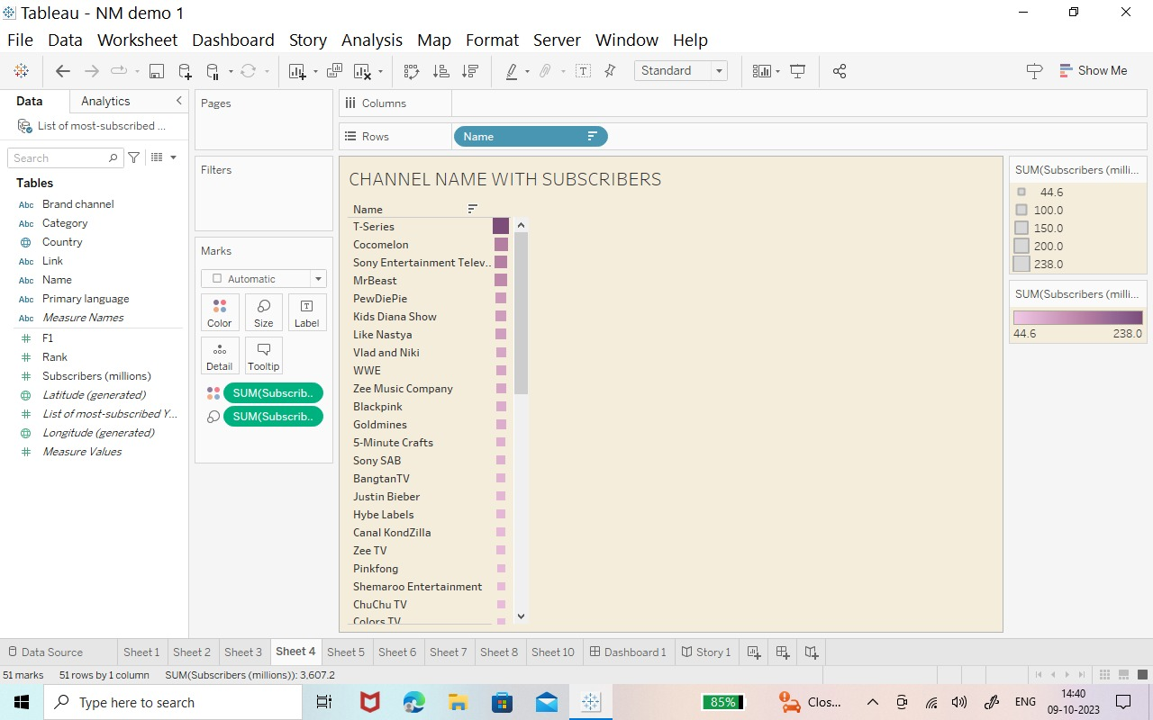

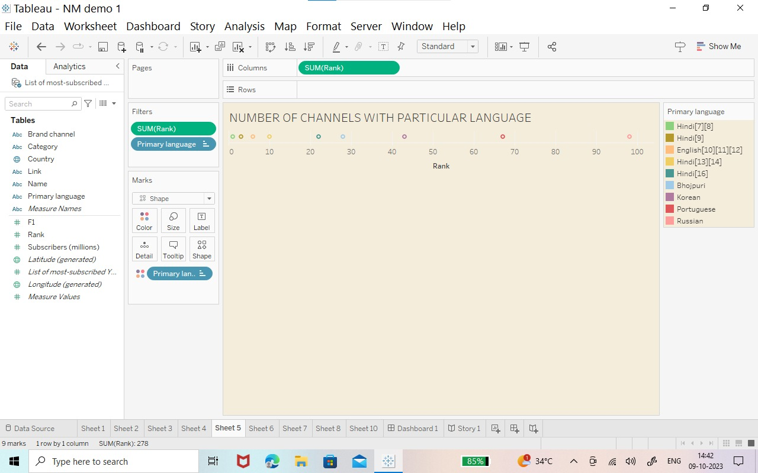

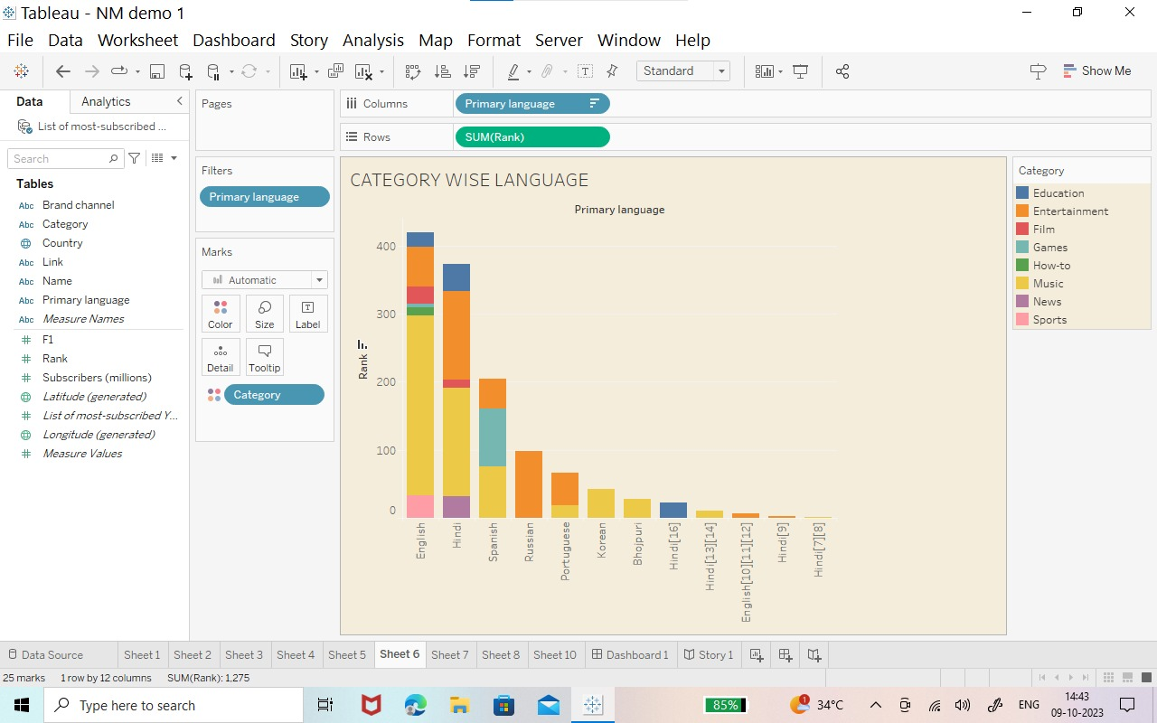

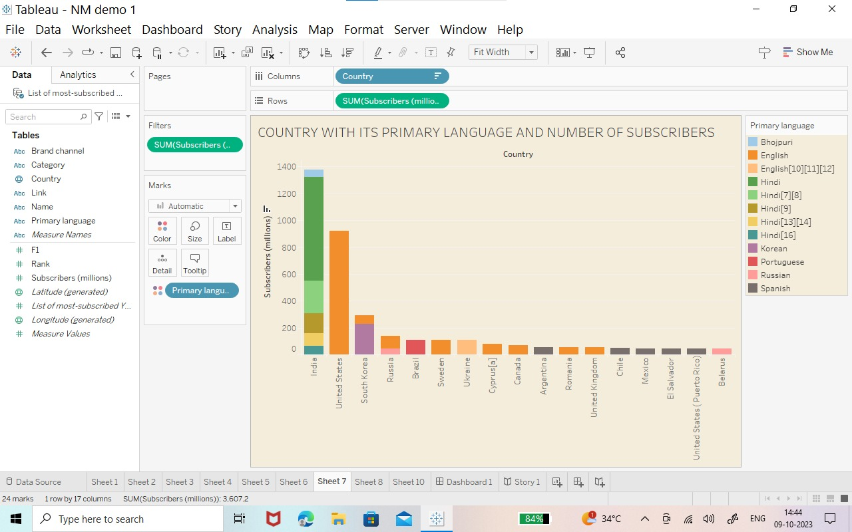

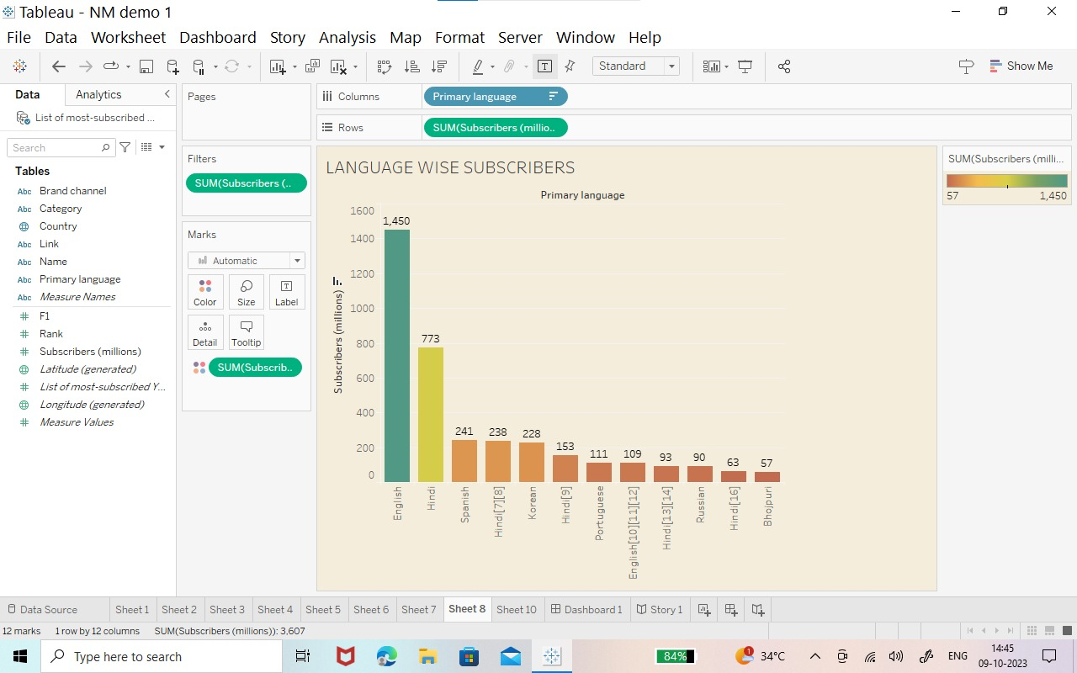

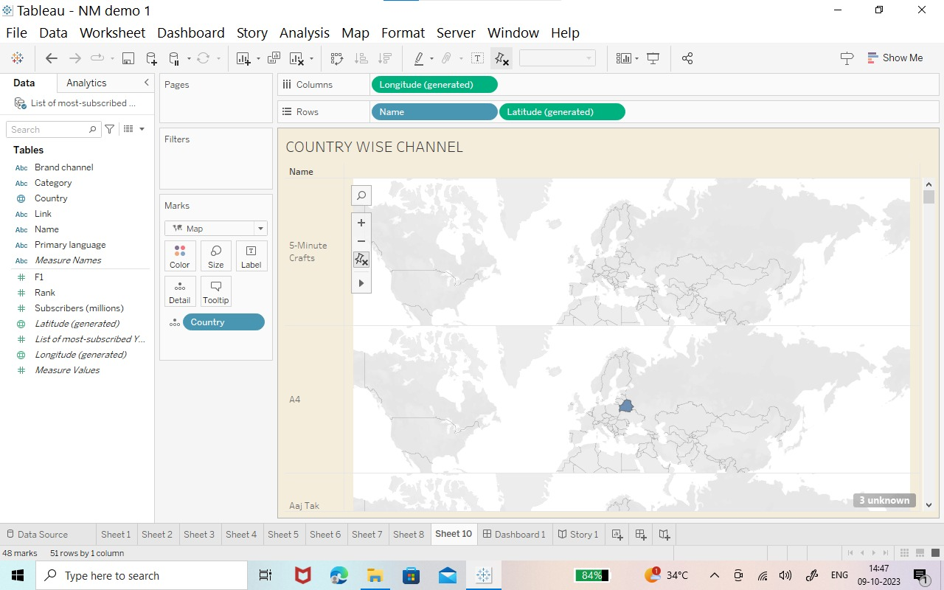

**4.Advantages&Disadvantages:**

**Advantage:**

*Youtube’s user friendliness

*Youtube for brand promotion

*Youtube benefit for talented people

*Publicity

*Creative outlet

*Modernizing

*Get outside your comfort zone

*Closer personal connection

*Kind of bussiness by giving advadasment

**Disadvantage:**

*Making money is not that easy

*Ads-a drawback of youtube for audience

**5.Conclution:**

Indian record laber T-Series is the most subscribed channel with over 250 million subscribers as on October 2023 american youtube personality Ms Beast is the most subscribed individual and second most subscribed channel over all ,with 194 million subscribers as on October 2023.

**6.Application:**

*Helpful in education ,researching ,cooking ,entertainment (games,mus,ic,pet,nature), religious activities,intustry purpose,etc.,

*Youtube is a video sharing service where user can watch,like,share,comment and upload their own videos.

**7.Future scope:**

It is a field that offers tremendous scope for growth and other benefits such as flexibility of work,the ability to express ourself ,opportunities to showcase our creations and a short at earning popularity and fame.